**Logic App**

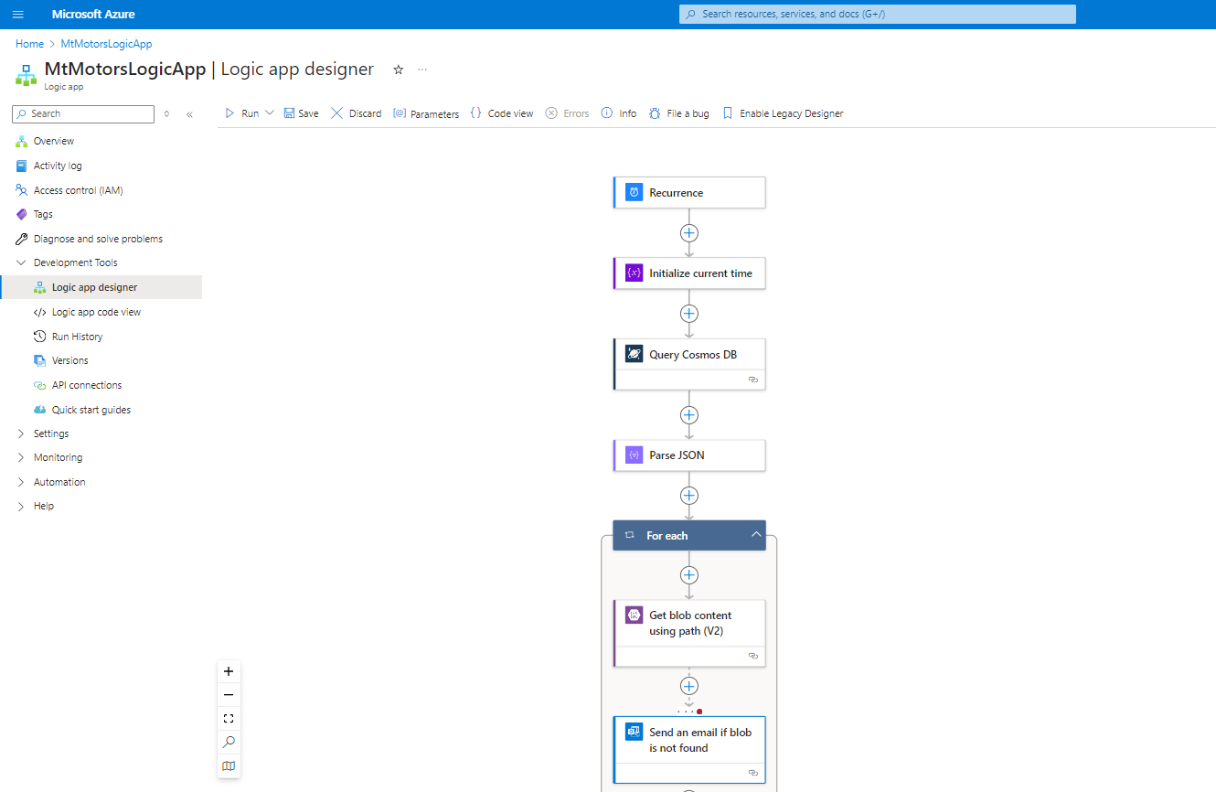

**Cosmos DB**

**Blob Storage**

Questions :

1. If the message were encrypted, I would store the keys for encryption in Azure Key Vault. The sender application will connect to Azure Key Vault to get the encryption key , encrypt the message and Send it to the Topic. Receiver application connects to Azure Key Vault for the encryption key and uses it to decrypt the message upon arrival.
2. If we need to apply security, I will use Azure role-based access control (Azure RBAC) to manage who has access to Azure resources and have restricted to members. Azure Storage supports authentication and authorization with Microsoft Entra ID for Blob storage and Service Bus. With Microsoft Entra authentication, we can use the Azure RBAC to grant specific permissions to users, groups, and applications down to the scope of an individual blob container or topic. With Service Bus , we can use IP firewall to restrict requests to set of IPv4 addresses or IPv4 address ranges. The IP firewall rules are applied at the Service Bus namespace level. Azure provides inbuilt security for Cosmos DB in terms of data replication for regional fail over scenarios, automatic data backups, Network security and firewall settings, User authentication and fine-grained user controls, Physical protection of servers in protected datacenters.